4

Dimensionality Reduction and Unsupervised Learning

*Present 1-2: The title slide and the Learning Objectives slide. An overview of what we will achieve in this course*

Lesson Objectives:

By the end of this lesson, you will be able to:

* Describe the differences between *supervised* and *unsupervised* learning
* Utilize loops for repetitive tasks
* Compare and contrast *Hierarchical Cluster Analysis (HCA)* and *k-Means clustering*
* Conduct a *HCA* and interpret the output
* Tune the number of clusters for *k-Means* clustering
* Select the optimal number of principal components for dimension reduction
* Generate predictions using *Linear Discriminant Function Analysis (LDA)* as a supervised classifier
* Tune hyperparameters using *GridSearchCV*
* Evaluate classifier model performance

Introduction

*Present 3: Brief summary of supervised and unsupervised learning*

In *supervised learning*, clear instruction is provided to *predictive models* concerning the outcome for which to learn. Supervised learning tasks are typically categorized as either *regression* or *classification*. Regression tasks consist of those problems where the dependent variable is *continuous*. Examples of regression tasks include predicting the temperature, rainfall, or weight. Classification tasks, on the other hand, involve those problems where the dependent variable is *categorical*. Examples of classification tasks include predicting if a team will win or if there will be snowfall. Unlike supervised learning models, unsupervised models do not have a dependent variable for which to predict.

Thus, in *unsupervised learning*, *descriptive models* are used for exploratory analysis to uncover patterns in unlabeled data. Examples of unsupervised learning tasks include algorithms for *clustering* and those for *dimension reduction*. In clustering, observations are assigned to groups in which there is high within-group homogeneity and between group heterogeneity. Simply put, observations are put into clusters of samples with other observations that are very similar. Use cases for clustering algorithms are vast. For example, analysts seeking to elevate sales by targeting select customers for marketing ads or promotions will separate customers by their shopping behavior. Additionally, hierarchical clustering has been implemented in academic neuroscience and motor behavior research (<https://www.researchgate.net/profile/Ming-Yang_Cheng/project/The-Effect-of-SMR-Neurofeedback-Training-on-Mental-Representation-and-Golf-Putting-Performance/attachment/57c8419808aeef0362ac36a5/AS:401522300080128@1472741784217/download/Schack+-+2012+-+Measuring+mental+representations.pdf?context=ProjectUpdatesLog>) and k-Means clustering has been used in fraud detection (https://www.semanticscholar.org/paper/Fraud-Detection-in-Credit-Card-by-Clustering-Tech/3e98a9ac78b5b89944720c2b428ebf3e46d9950f).

However, when building predictive or descriptive models, it can be a challenge to determine which features to include in the model to improve the model and which features to exclude because they diminish the model. Too many features can be troublesome because the greater the number of variables in a model the higher the probability of *multicollinearity* and subsequent *overfitting* of the model. Additionally, numerous features expand the complexity of the model and increase the time for model tuning and fitting. This becomes troublesome and aggravating with larger data sets. Fortunately, another use case for unsupervised learning is to reduce the number of features in a data set by creating combinations of the original features. Reducing the number of features in the data helps eliminate multicollinearity and converges on a combination of features to best produce a model that performs well on unseen, test, data.

***Note***

*Multicollinearity is a situation in which at least two variables are strongly correlated. Multicollinearity is a problem in linear regression models because it does not allow the isolation of the relationship between each independent variable and the outcome measure. Thus, coefficients and p-values become unstable and less precise.*

In this chapter we will be covering two widely used unsupervised clustering algorithms: *Hierarchical Cluster Analysis (HCA)* and *k-Means clustering*. Additionally, we will explore dimension reduction using *Principal Component Analysis (PCA)* and observe how reducing dimensionality can improve model performance. Lastly, we will implement *Linear Discriminant Function (LDA)* Analysis, an algorithm that can be used for data reduction and classification, as a supervised classifier. We will tune the LDA model using a grid search and interpret the output.

Hierarchical Cluster Analysis (HCA)

*Present 4-5: Introduction to HCA and interpreting dendrograms*

Hierarchical cluster analysis (HCA) is best implemented when the user does not have an *a priori* number of clusters for which to build. HCA works measuring the *Euclidean distance* between and among all observations in the data and creates links at the distance in which the two points lie.

With the number of features indicated by *n*, Euclidean distance is calculated using the formula:

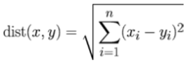

Equation 4.1. Euclidean Distance (https://books.google.com/books?hl=en&lr=&id=ZaJNCgAAQBAJ&oi=fnd&pg=PP1&dq=machine+learning+with+R+2015&ots=BfyzNB-RL3&sig=TrhKLOnDaC316Nv7S3SjotTyKlQ#v=onepage&q=machine%20learning%20with%20R%202015&f=false)

For example, if we compare a subject with 2 cars and 1 boat to a subject with 3 cars and 0 boats, we would determine the distance in Python by, first, importing the math library to access the sqrt function.

***Note***

In Python, **2 is used to square a number.

By wrapping the two squared numbers in the math.sqrt function we are able to get the square root of the sum of those values. To print values to the console, call the print function. To format the number along with the text, place {} in the area the value is supposed to appear. In the example below, the double brackets contain 0:0.2f. The zero prior to the colon references the index of the number to be formatted and the 0.2f rounds the formatted value to 2 decimal places.



After the distance between observations and groups of observations have been calculated, the relationships between and among all observations are displayed using a dendrogram. Dendrograms are tree-like structures displaying horizontal lines at the distance between links. Dr. Thomas Schack (<https://www.researchgate.net/profile/Ming-Yang_Cheng/project/The-Effect-of-SMR-Neurofeedback-Training-on-Mental-Representation-and-Golf-Putting-Performance/attachment/57c8419808aeef0362ac36a5/AS:401522300080128@1472741784217/download/Schack+-+2012+-+Measuring+mental+representations.pdf?context=ProjectUpdatesLog>) relates this structure to the human brain in which each observation is a node and the links between observations are the neurons. This creates a hierarchical structure in which those items that are more closely related are “chunked” together into clusters. An example dendrogram from the scipy.cluster.hierarchy.dendrogram(https://docs.scipy.org/doc/scipy-0.14.0/reference/generated/scipy.cluster.hierarchy.dendrogram.html) documentation site is displayed below.

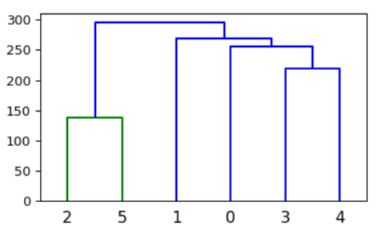

Figure 4.1. Example dendrogram

The y-axis indicates the Euclidean distance while the x-axis indicates the row index for each observation. Horizontal lines denote links between observations with links closer to the x-axis indicating closer distance and subsequent relationship. There appear to be two clusters in this example. The first cluster includes indices 2 and 5 while the second cluster includes indices 1, 0, 3, and 4.

*Discuss situations in which HCA may be of use*

Exercise 1: Segmenting Flower Species using HCA

To demonstrate HCA, we will be using the well-known iris data set from sklearn.datasets (https://scikit-learn.org/stable/datasets/index.html). This data is widely-used for tutorials on clustering and classification by using 4 flower attributes (sepal length, sepal width, petal length, and petal width) to predict 3 Iris flower species (Iris Setosa, Iris Versicolor, and Iris Virginica). It is a small data set with only 150 rows and 4 columns. In this exercise, we will using flower attributes to segment flower species. Until the last section of the chapter where we use LDA as a supervised classifier, we will not include the dependent variable, flower species, in the data. Thus, the iris data set will predominantly be used to demonstrate clustering and data reduction techniques.

1. To get started, we must first import the Iris utilities bundle from sklearn.datasets ([*https://scikit-learn.org/0.16/modules/generated/sklearn.datasets.load_iris.html#sklearn.datasets.load_iris*](https://scikit-learn.org/0.16/modules/generated/sklearn.datasets.load_iris.html#sklearn.datasets.load_iris)). To load the bundle, call the load_iris() function from the sklearn.datasets library and save it to the object iris.



1. By calling iris.data we can access only the features from the irisobject. To save the features as a pandas data frame we must import pandas using import pandas as pd, wrap iris.data in the pd.DataFrame function, and assign to the object, df.



1. To explore the dimensions of the data and print the information to the console access the number of rows and columns by calling df.shape. This returns a tuple with rows as the first index and columns as the second index. To access the rows use df.shape[0]. To access the columns use df.shape[1]. The number of rows and columns will be saved as the objects n_rows and n_columns, respectively. To print these values to the console by concatenating strings and values we will be using {} in both places where we want to insert the values.

***Note***

Since we are not formatting these values, we will not need to specify a series of digits followed by f. Additionally, the values will appear in the brackets in the order in which they are provided in the parenthesis following the format function. To clarify, since n_rows is listed first in the parenthesis following the format function it will appear in place of the first {}. Since n_columns appears second in the parenthesis following the format function, it will appear in place of the second {}.



1. We can also look for some basic data frame information by printing df.info() to the console.

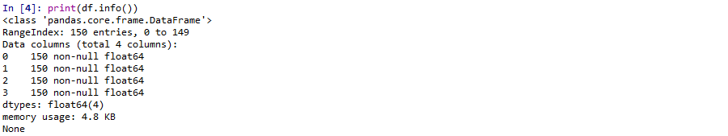

From the output, we can see that there are 150 entries (I.e., rows) and 4 columns. We can also see that there are no missing values (I.e., all are non-null) and that the data type for each column is float64. Float numbers are named accordingly because they are floating-point numbers, meaning they are a number that contains a decimal point.

1. It is good practice to remove any possible order effects in the data by shuffling the rows prior to building any models. To shuffle the data, we will import the shuffle function from sklearn.utils using from sklearn.utils import shuffle. The shuffle function takes arrays, lists, data frames or scipy sparse matrices as the first argument, random_state as another argument, and returns a shuffled copy of the first argument, df_shuffled.

***Note***

random state is used for initializing the internal random number generator. If it is not specified, then the data will be shuffled differently each time. For reproducibility, it is suggested to set a random_state. Random state is included as an argument in many Python functions. To keep everything as consistent and reproducible as possible we will always set it to 42.



In machine learning models, larger numbers carry more weight than smaller ones which leads to erroneous conclusions. To ensure features measured at different scales contribute equally to the analysis, models perform much better when they are standardized. For example, in sports win percentage is standardized by number of games played, whereas total wins are not standardized. In a machine learning model, the total wins feature will carry more weight than the win percentage feature even though the win percentage provides more information. Typically, variables are scaled prior to being implemented as a part of any model. Scikit-Learn provides us with a built-in z-score transformation function termed StandardScaler ([*https://scikit-learn.org/stable/modules/generated/sklearn.preprocessing.StandardScaler.html*](https://scikit-learn.org/stable/modules/generated/sklearn.preprocessing.StandardScaler.html)) so we do not have to write our own z-score transformation function. The z-score is calculated using the formula below.



Equation 4.2. Z-score standardization formula (https://books.google.com/books?hl=en&lr=&id=ZaJNCgAAQBAJ&oi=fnd&pg=PP1&dq=machine+learning+with+R+2015&ots=BfyzNB-RL3&sig=TrhKLOnDaC316Nv7S3SjotTyKlQ#v=onepage&q=machine%20learning%20with%20R%202015&f=false)

1. Transform each observation into a z-score using sklearn.preprocessing.StandardScaler. First, import StandardScaler using from sklearn.preprocessing import StandardScaler. Next, instantiate a StandardScaler() and save it as the object scaler. Fit the scaler object to df_shuffled using scaler.fit(df_shuffled). Lastly, transform df_shuffled to z-scores and save it as the object scaled_features using scaled_features = scaler.transform(df_shuffled).

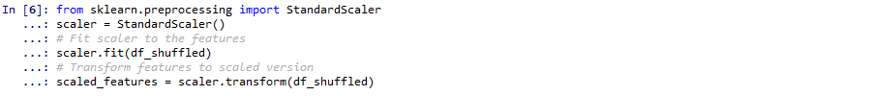

1. Build the HCA model by importing linkage (https://docs.scipy.org/doc/scipy/reference/generated/scipy.cluster.hierarchy.linkage.html) using from scipy.cluster.hierarchy import linkage. Build our linkage model and save it as the model object using model = linkage(scaled_features, method=’complete’). By default, linkage uses Euclidean distance as its metric argument, so we do not need to specify it.



***Note***

Scikit-Learn also has a function for HCA (*https://scikit-learn.org/stable/modules/generated/sklearn.cluster.AgglomerativeClustering.html#sklearn.cluster.AgglomerativeClustering)*, but it is easier to visualize the dendrogram by using the *scipy* library.

1. To display the dendrogram we will plot the linkage model using the dendrogram function (*https://docs.scipy.org/doc/scipy-0.14.0/reference/generated/scipy.cluster.hierarchy.dendrogram.html*). To plot the linkage model, import matplotlib using import matplotlib.pyplot as plt. Next, import the dendrogram function using from scipy.cluster.hierarchy import dendrogram. Edit the size of our plot using plt.figure(figsize=(10,5)). To title our plot “Dendrogram”, use plt.title(‘Dendrogram’). To plot the dendrogram, rotate the x tick labels 90 degrees, and make the font size 6, use dendrogram(model, leaf_rotation=90, leaf_font_size=6). Finally, to display the plot use plt.show().

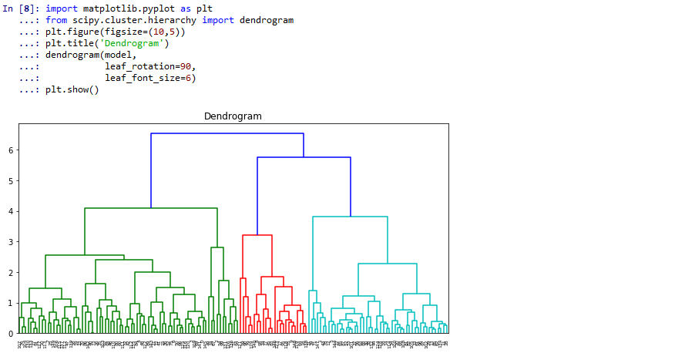

On the x-axis is the index for each observation, or row, in the data set. On the y-axis is Euclidean distance. Horizontal lines are links between and among observations. By default, scipy will color code the different clusters that it finds. However, a manual method for determining the optimal number of clusters is to find the maximal (vertical) distance between links and count the vertical lines in that area. In this case, it would be three as the maximal distance between links contains 3 vertical lines.

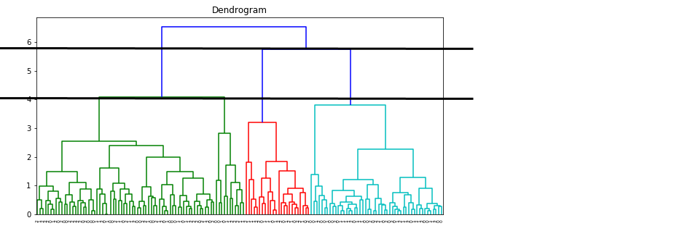

Now that we have the predicted clusters of observations, we can use the fcluster function (*https://docs.scipy.org/doc/scipy-0.14.0/reference/generated/scipy.cluster.hierarchy.fcluster.html*) from scipy.cluster.hierarchylibrary to generate an array of labels that correspond to the rows in df_shuffled and scaled_features.

1. To generate the predicted labels of the cluster for which an observation belongs, use the fcluster function from scipy.cluster.hierarchy ([*https://docs.scipy.org/doc/scipy-0.14.0/reference/generated/scipy.cluster.hierarchy.fcluster.html*](https://docs.scipy.org/doc/scipy-0.14.0/reference/generated/scipy.cluster.hierarchy.fcluster.html)). To access the fcluster function, use from scipy.cluster.hierarchy import fcluster. Using the fcluster function, use the linkage model as the first argument, 5 for the threshold to apply when forming flat clusters, and ‘distance’ for the criterion argument so that each cluster can have no greater distance than 5, and save them as labels.

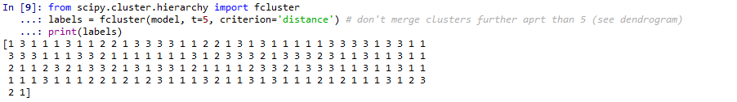

1. Now that the labels have been generated for each observation, we can add them as a column in either the df_shuffled or scaled_features data frames.

***Note***

Remember, we cannot add labels to any data frames generated before being shuffled because labels were generated on the data after being shuffled. Thus, the order of the values of labels do not match with the order of the observations in the data prior to being shuffled.

To add labels as a column in df_shuffled, assign labels to df_shuffled[‘Predicted_Cluster’] using df_shuffled[‘Predicted_Cluster’] = labels. This code creates a new column called ‘Predicted_Cluster’ to df_shuffled and assigns that column the values of labels.



We have successfully learned the differences between supervised and unsupervised learning, how to format numbers in text, how to import data from sklearn.datasets, save the features as a pandas data frame, data preprocessing (I.e., shuffling and scaling) steps, how to build an HCA model using scipy.cluster.hierarchy.linkage, how to visualize the HCA dendrogram using scipy.cluster.hierarchy.dendrogram and interpret it, and how to assign predicted cluster labels to observations.

Here we have utilized HCA to cluster our data into three groups and matched the observations with their predicted cluster. While HCA models are easy to build, there’s no need to specify a number of clusters in advance, and the visualizations make sense and are fairly easy to interpret it has its drawbacks as well. For example, there is some vagueness in terms of the termination criteria (I.e., when to finalize the number of clusters). Additionally, the algorithm cannot make adjustments once the clustering decisions have been made. Lastly, it can be very computationally expensive to build HCA models on large data sets with many features (https://www.sciencedirect.com/science/article/pii/S1877050916001368).

Next, we will be introducing you to another clustering algorithm, k-Means clustering. This algorithm addresses some of the shortcomings of HCA by having the ability to make adjustments when the clusters have been initially generated and being less computationally expensive than HCA.

K-Means Clustering

*Present 8-12: Brief explanation of how k-Means works*

K-Means also uses distance to cluster observations. However, rather than linking observations to each other as in HCA, k-Means assigns *n* observations (I.e., number of rows) to *k* (number of) clusters. To determine which observations belong to which clusters, observations are assigned to the cluster in which it’s Euclidean distance is closest to the cluster center. Like the starting weights in artificial neural networks, cluster centers are generated at random which means that the randomness may have a large effect as to the clusters in which observations are assigned. After the cluster centers have been randomly generated there are two phases: 1) assignment phase and 2) updating phase.

***Note***

The cluster centers being randomly generated is an important point to remember and we will be visiting it later in the chapter. Some refer to this random generation of cluster centers as a weakness of the algorithm, but we can turn it into a strength by leveraging the power of loops.

In the assignment phase, observations are assigned to the cluster from which it has the smallest Euclidean distance.

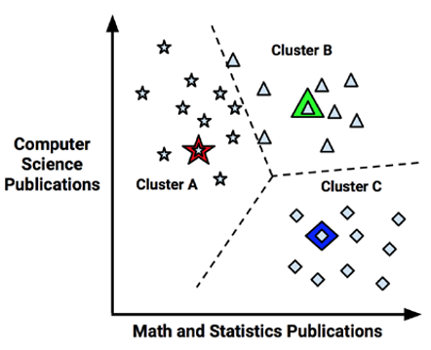

Figure 4.2. A scatterplot of observations and the cluster centers as denoted by the star, triangle, and diamond (https://books.google.com/books?hl=en&lr=&id=ZaJNCgAAQBAJ&oi=fnd&pg=PP1&dq=machine+learning+with+R+2015&ots=BfyzNB-RL3&sig=TrhKLOnDaC316Nv7S3SjotTyKlQ#v=onepage&q=machine%20learning%20with%20R%202015&f=false).

Next, in the updating phase, cluster centers are shifted to the mean position of the points in that cluster. These cluster means are known as the centroids.

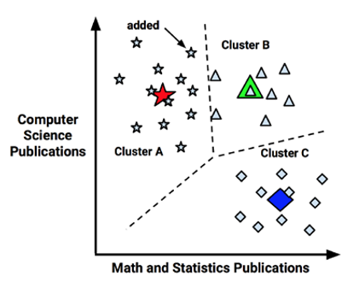

Figure 4.3. Shifting of the cluster centers to the cluster centroid (https://books.google.com/books?hl=en&lr=&id=ZaJNCgAAQBAJ&oi=fnd&pg=PP1&dq=machine+learning+with+R+2015&ots=BfyzNB-RL3&sig=TrhKLOnDaC316Nv7S3SjotTyKlQ#v=onepage&q=machine%20learning%20with%20R%202015&f=false).

However, once the centroids have been calculated, some of the observations are reassigned to a different cluster due to being closer to the new centroid than the previous cluster center. Thus, the model must update its centroids once again.

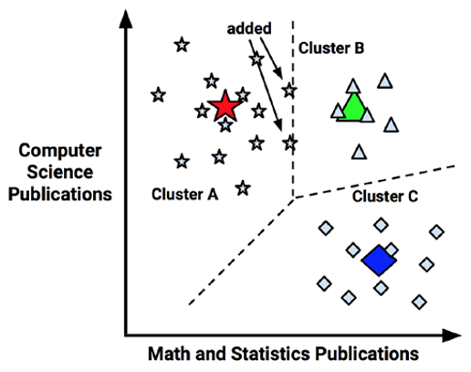

Figure 4.4. Updating of the centroids after observation reassignment (<https://books.google.com/books?hl=en&lr=&id=ZaJNCgAAQBAJ&oi=fnd&pg=PP1&dq=machine+learning+with+R+2015&ots=BfyzNB-RL3&sig=TrhKLOnDaC316Nv7S3SjotTyKlQ#v=onepage&q=machine%20learning%20with%20R%202015&f=false>).

This process of updating centroids continues until there are no further observation reassignments.

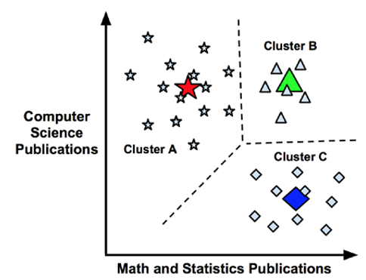

Figure 4.5. Final centroid position and cluster assignments (<https://books.google.com/books?hl=en&lr=&id=ZaJNCgAAQBAJ&oi=fnd&pg=PP1&dq=machine+learning+with+R+2015&ots=BfyzNB-RL3&sig=TrhKLOnDaC316Nv7S3SjotTyKlQ#v=onepage&q=machine%20learning%20with%20R%202015&f=false>).

Using the iris data set from sklearn.datasets, we will, first, fit a k-Means (https://scikit-learn.org/stable/modules/generated/sklearn.cluster.KMeans.html)model with a user-defined number of clusters. Next, because of the randomness in which group centroids are chosen, we will increase the confidence in our predictions by building an ensemble of k-Means models with a given number of clusters and assigning each observation to the mode of the predicted clusters. After that, we will tune the optimal number of clusters by monitoring the inertia, or within-cluster homogeneity, by number of clusters and finding the point at which there are diminishing returns in inertia by adding more clusters. Lastly, we will further improve the confidence of our clusters by building an ensemble of k-Means models at each number of clusters and, again, finding the point of diminishing returns.

Exercise 2: Segmenting Iris into 2 Clusters using k-Means

After the iris data set has been imported, shuffled, and standardized (see Exercise 1):

1. Instantiate a KMeans model by, first, importing the KMeans function from sklearn.cluster using from sklearn.cluster import KMeans with, in this case, 2 clusters. We assign the number of clusters a priori by assigning a number to the KMeans argument n_clusters and assigning it to the object model.



1. Fit the model to scaled_features using model.fit(scaled_features). After the model has been fit, we can see the hyperparameters that the model is using. The algorithm completes the assignment phase and updating phase for us.

***Note***

We will be discussing hyperparameters in greater detail later in the chapter when we discuss tuning models using a grid search.



1. Return the coordinates of the group centroids and save them to the object centroids using centroids = model.cluster_centers_. Since we told the algorithms that we wanted 2 clusters we see that there are two rows in the centroids array. Additionally, there are 4 features in the data so we return 4 columns in the centroids array.



1. To return the inertia for our model with 2 clusters we use model.inertia_ and save the value to the object inertia. We also print the formatted inertia value to the console along with text using {0:0.2f} in the area where we want to place our value.



1. To access the cluster labels from our model we use model.labels_ and assign the value to the labels object. Since we chose 2 clusters, there are 2 possible labels; 0 and 1. If we chose to have 3 clusters, we would have 3 possible labels; 0, 1, and 2.

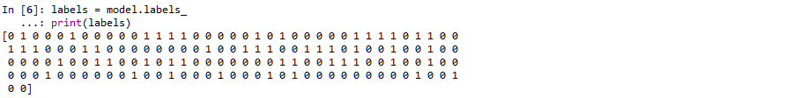

1. It is a good idea to generate a frequency table of the labels using the pandas function value_counts. To examine the frequency of each cluster, import pandas as pd and then create the frequency table using pd.value_counts(labels). Using 2 clusters, 100 observations were placed into the first cluster and 50 observations were grouped into the second cluster.

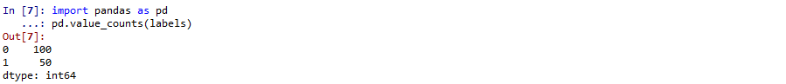

1. Match the label with the observation by adding *label* as a column on the *df_shuffled* data frame and view it by previewing the first 5 rows.

Now that we have the labels generated for each observation, we can add them as a column in either the df_shuffled or scaled_features data frames. To add labels as a column in df_shuffled, we will assign labels to df_shuffled[‘Predicted_Cluster’] using df_shuffled[‘Predicted_Cluster’] = labels. This code creates a new column called ‘Predicted_Cluster’ to df_shuffled and assigns that column the values of labels. We will then use df_shuffled.head(5) to preview the first 5 rows of df_shuffled after the ‘Predicted_Cluster’ column has been created.

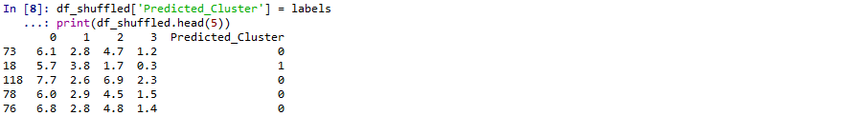

*Discuss: How confident are we in these predictions? Why might we lack confidence in these predictions? What can we do to increase the confidence we have in our predictions?*

However, it is important to remember that the initial group centers were chosen at random, so the next time we run the k-Means analysis, even on the exact same data, we will get different results. Thus, building an ensemble of models (I.e., numerous models), and taking an average or mode of those models may be used to generate more stable predictions.

Activity 1: K-Means Clustering (ensemble)

When algorithms use randomness as part of their method for finding the optimal solution (I.e., in Artificial Neural Networks and k-Means clustering), running back-to-back models may result in very different conclusions. Thus, it is advised to run these types of models many times and generate predictions using a summary measure across all models (I.e., mean, median, mode). In this activity, we will build an ensemble of 100 k-Means clustering models and keep the label for each observation that occurs most frequently (I.e., the mode).

After the iris data set has been imported, shuffled, and standardized (see Exercise 1):

1. Instantiate an empty data frame for which to append the labels for each model and save it as the new data frame object labels_df.
2. Using a for loop, iterate through 100 models, appending the predicted labels to labels_df to a new column each time named after the iteration it was generated. This will result in labels_df containing 100 columns at the end of the loop.
3. Calculate the mode for each row and assign it to the column ‘row_mode’ in labels_df.
4. Print a frequency table of labels_df[‘row_mode’].

**Solution:**

After the iris data set has been imported, shuffled, and standardized (see Exercise 1):

1. Instantiate an empty data frame for which to append the labels for each model and save it as the new data frame object labels_df using import pandas as pd to access the pandas library and labels_df = pd.DataFrame() to create the empty data frame.



1. First, import the KMeans function using from sklearn.cluster import KMeans. Then, we decide a range through which to iterate. We want to build 100 models, so we could use for i in range(100). This range of values will return numbers 0 through 99. However, after each iteration we want to add a column named after the iteration. For example, for the first iteration we want a column added to labels_df named Model_1_Labels. So, to loop through the values 1 through 100, we must use for i in range(1, 101):.
   1. Save a KMeans model object with 2 clusters (decided upon *a priori*) using model = KMeans(n_clusters=2).
   2. Fit the model to scaled_features using model.fit(scaled_features).
   3. Generate the labels and save them to the labels object using labels = model.labels_.
   4. Store labels as a column in labels_df named after the iteration using labels_df[‘Model_{}_Labels’.format(i)] = labels. After each iteration, i will be replaced with the iteration 1 through 100 resulting in 100 columns in the previously empty labels_df.

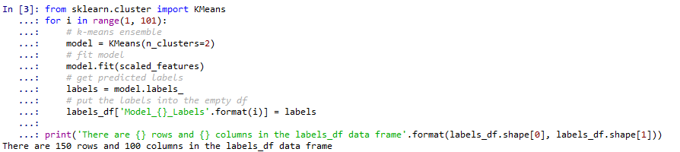

1. To calculate the mode for each row and assign it to a new column in labels_df entitled row_mode, use labels_df[‘row_mode’] = labels_df.mode(axis=1). The argument axis=1 computes across all columns. The default, axis=0 computes down all rows.



1. If we wish to generate a frequency table of the row_mode column inside of labels_df, we will use the pandas function value_counts. To examine the frequency of each cluster, import pandas as pd and then create the frequency table using pd.value_counts(labels_df[‘row_mode’). In this case, the frequency of labels after running 100 models is the same as the frequency of labels after running it once. However, we can be more confident in our predictions after running our models through hundreds or even thousands of iterations. Additionally, iterating through an ensemble of models and calculating a mean and standard deviation across models allows us to report the variability and confidence levels of our predictions.

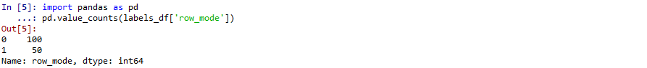

*Discuss: How confident are we in the predictions now that we have computed them from 100 models as opposed to 1? How can we further increase our confidence that we have appropriately segmented this sample?*

If we know beforehand that we want to separate these observations into 2 clusters, then our work here is done.

However, in unsupervised learning, it is probable that we do not know how many clusters for which to choose. Thus, to find the best value of n_clusters, we must decide over a range of n_clusters.

Exercise 3: k-Means clustering: Tuning n_clusters

To tune the number of clusters, we must think of an outcome measure that determines how well a k-Means model is performing. In k-Means, model performance is interpreted in terms of sum of squared distances of samples to their closest cluster centroid, or *inertia*. Thus, to determine which number of clusters produces the best model we need to run a different model for each number of n_clusters in a given range and see which value of n_clusters results in the smallest inertia, right? No, we want the smallest number of n_clusterswhile still minimizing the value for inertia. Therefore, we determine the value for n_clusters by running a separate model for each value of n_clusters and plotting inertia. The number of clusters where the decrease in inertia begins to level-off (I.e., there are diminishing returns with more n_clusters) will be considered the best choice for n_clusters.

To demonstrate tuning the number of n_clusters, first, import, shuffle, and standardize the iris data (see Exercise 1).

1. Import the KMeans function using from sklearn.cluster import KMeans.
2. Instantiate an empty list for which the inertia values will be stored after every iteration entitled inertia_list.
3. Next, instantiate a for loop to iterate through the each integer in the range 1-10 using for i in range(1, 11):.
4. Build a KMeans model with the argument n_clusters equaling the value for i using model = KMeans(n_clusters=i).
5. Fit the model to scaled_features using model.fit(scaled_features).
6. Return the inertia and store the value in the object inertia using inertia = model.inertia_.
7. Append inertia it to inertia_list using inertia_list.append(inertia).

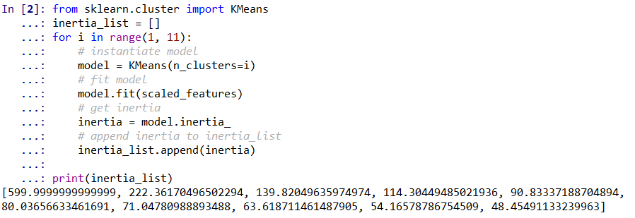

1. Now that we have a list of inertia values for each value of n_clusters, we can plot inertia by number of clusters by, first, importing matplotlib (https://matplotlib.org/api/_as_gen/matplotlib.pyplot.html) using import matplotlib.pyplot as plt.
2. Create a list of numbers and save it as the object x so we can plot it on the x-axis using x = list(range(1,11)).
3. Save inertia_list as the object y using y = inertia_list.
4. Plot inertia by number of clusters using plt.plot(x, y).
5. Set the plot title to read ‘Inertia by n_cluster’ using plt.title(‘Inertia by n_clusters’).
6. Label the x-axis ‘n_clusters’ using plt.xlabel(‘n_clusters’).
7. Set the tick labels on the x-axis as the values in x use plt.xticks(x).
8. Sset the y-axis label to ‘Inertia’ using plt.ylabel(‘Inertia’).
9. Display the plot use plt.show().

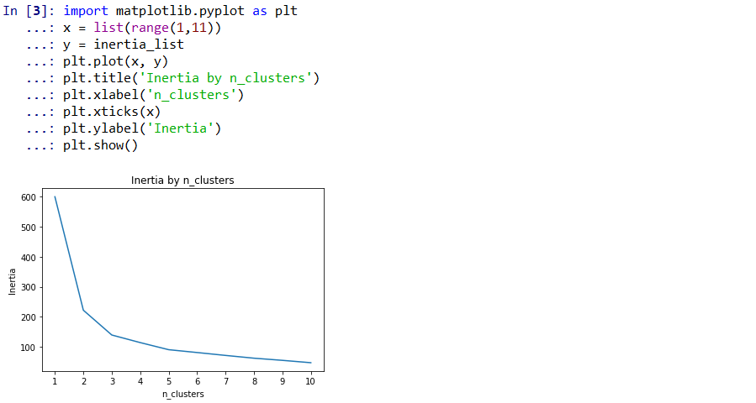

The distance (I.e., inertia) between observations and cluster centroids will always decrease as n_clusters increase. However, we want the smallest number of clusters possible with the smallest inertia possible. Therefore, we will use the “elbow” method for determining n_clusters. The elbow method involves finding the point where there are diminishing returns from selecting more clusters. For example, using the plot above, when we increase n_clusters from 1 to 2 we see a significant drop in inertia. When we increase n_clusters from 2 to 3 there is still a pronounced decrease in inertia. However, after 3 clusters the decreases in inertia are less pronounced and the decrease in inertia after 3 clusters is not worth the added complexity from adding more clusters. Thus, the number of clusters we would choose in this situation is 3.

*Discuss: How confident are we that n_clusters = 3 is the best number of n_clusters for this sample? Why might we lack confidence in this number of n_clusters? What can we do to increase the confidence we have in the number of n_clusters?*

However, it is important to remember that each time one of these models was fit it was done so using random cluster centers. So, it is possible that if we ran these 10 models again that we could get a different number for the optimal value of clusters. To increase our confidence that 3 is the optimal number of clusters we will run each of the same 10 models 100 times and take a summary statistic over the 100 predicted labels.

Exercise 4: Tuning n_clusters using Ensembles

Previously, when we built an ensemble of models, we chose one value for n_clusters and iterated over it 100 times to generate more stable predictions. After that, we looked to tune the number of clusters by iterating over a range of values for n_clusters. But only 1 model was built for each possible value of n_clusters, and knowing that each time a k-Means model is fit with random cluster centers, we had some question marks regarding our confidence in the optimal number of n_clusters. Thus, to improve our confidence in the tuned number of clusters for our k-Means model we will expand our skillset and knowledge of loops by combining both of our previous loops into one, nested loop. A nested loop is a loop occurring inside of another loop. We will use a nested loop to find the best number of clusters by iterating through 10 possible values for n_clusters and building 100 models for each value of n_clusters.

After the iris data set has been imported, shuffled, and standardized (see Exercise 1):

1. Import the packages we need outside of the loop using from sklearn.cluster import KMeans and import numpy as np.

***Note***

We import our packages outside the loop so we do not waste time and computational resources importing the packages at every iteration when we do not need to.

1. It is easier to build and comprehend nested loops by working from the inside-out. First, instantiate an empty list, inertia_list, for which we will be appending inertia values after each iteration of the inside loop using inertia_list = [].
2. In the inside loop, we will iterate through 100 models using for i in range(100):.
3. Build KMeans model with n_clusters=x using model = KMeans(n_clusters=x).

***Note***

The value for x is determined by the outer loop, which we have not covered yet, but we will cover in detail very shortly.

1. Fit the model to scaled_features using model.fit(scaled_features).
2. Get the inertia value and save it to the object inertia using inertia = model.inertia_.
3. Append inertia it to inertia_list using inertia_list.append(inertia).

***Note***

After all 100 iterations of n_clusters=x have concluded, inertia_list will contain 100 inertia values; one for each model.

1. Moving to the outside loop, instantiate another empty list to store the average inertia values using mean_inertia_list = [].
2. Since we want to check the average inertia over 100 models for n_clusters equaling 1 through 10, instantiate the outer loop using for x in range(1, 11):. The value for x will dictate the value for n_clusters and since it is on the outside, it will not move to the next value of x until the inner loop has iterated through its 100 loops.
3. After the inside loop has run through its 100 iterations, and the inertia value for each of the 100 models have been appended to inertia_list, compute the mean of this list and save the object as mean_inertia using mean_inertia = np.mean(inertia_list).
4. Append mean_inertia to mean_inertia_list using mean_inertia_list.append(mean_inertia).
5. After 100 iterations have been completed 10 times for a total of 1000 iterations, mean_inertia_list contains 10 values that are the average inertia values for each value of n_clusters. This allows us to plot mean_inertia by n_clusters and choose the optimal number of n_clusters using the, previously described, “elbow” method.

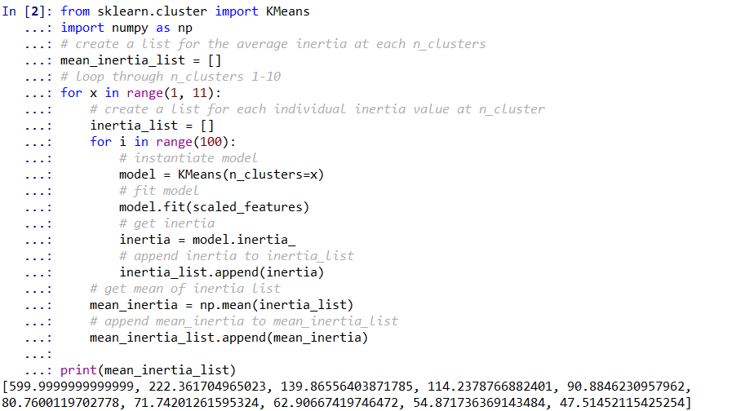

1. Plot mean_inertia by number of clusters by, first, importing matplotlib (https://matplotlib.org/api/_as_gen/matplotlib.pyplot.html) using import matplotlib.pyplot as plt.
2. Create a list of numbers and save it as the object x so we can plot it on the x-axis using x = list(range(1,len(mean_inertia_list)+1)).
3. Save mean_inertia_list as the object y using y = mean_inertia_list.
4. Plot mean inertia by number of clusters using plt.plot(x, y).
5. Set the plot title to read ‘Mean Inertia by n_clusters’ using plt.title(‘Mean Inertia by n_clusters’).
6. Label the x-axis ‘n_clusters’ using plt.xlabel(‘n_clusters’).
7. Set the tick labels on the x-axis as the values in x using plt.xticks(x).
8. Set the y-axis label to ‘Mean Inertia’ using plt.ylabel(‘Mean Inertia’).
9. Display the plot use plt.show().

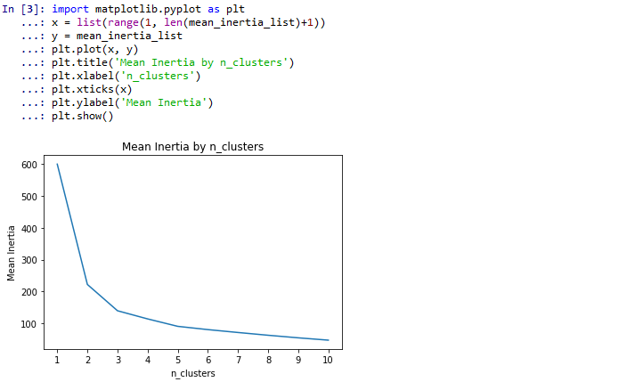

***Note***

Again, using the elbow method, 3 is the best value for n_clusters. But this time we can make this claim because we have 1000 models to base this on rather than 10.

1. Print the message ‘When n_clusters = 3, inertia = 139.87’ programmatically, that is when the mean inertia value for n_clusters = 3 changes upon running the code again, using print(‘When n_clusters = 3, inertia = {0:0.2f}’.format(y[2]).

***Note***

As mentioned previously in the chapter, by placing 0:0.2f inside of {}, we will format the value to 2 decimal places. The value we are formatting is the third value in the list y, thus we must access index 2 using y[2].



*Discuss: How confident are we that n_clusters = 3 now that we have concluded this from 1000 models as opposed to 10? Now that we know the best value for n_clusters, how might we improve upon this model?*

However, if the data has too many dimensions, the k-Means algorithm can fall subject to the *curse of dimensionality* by inflated Euclidean distances and subsequent erroneous results. Thus, before fitting a k-Means model, using a dimension reduction strategy is encouraged (<https://scikit-learn.org/stable/modules/clustering.html#k-means>).

Reducing the number of dimensions helps to eliminate multicollinearity and decreases the time to fit the model. *Principal component analysis (PCA)* is a common method to reduce the number of dimensions by discovering a set of underlying linear variables in the data.

Principal Component Analysis (PCA)

*Present 18-19: Brief intorduction of Principal Component Analysis*

At a high level, PCA is a technique for creating uncorrelated linear combinations from the original features termed *components*. Of the principal components, the first component explains the greatest proportion of variance in the data while the following components account for progressively less variance (https://scikit-learn.org/stable/modules/generated/sklearn.decomposition.PCA.html).

To demonstrate PCA, we will:

* Show how to extract a user-defined number of principal components
* Tune the number of principal components by setting a threshold of explained variance to remain in the data
* Fit those components to a k-Means cluster analysis and compare k-Means performance before and after the PCA transformation

Exercise 5: PCA with 2 Principal Components

After the iris data set has been imported, shuffled, and standardized (see Exercise 1):

1. Import the PCA function using from sklearn.decomposition import PCA. Then, instantiate a PCA model with, in this case, 2 principal components using model = PCA(n_components=2).

***Note***

The number for n_components can be whatever you want it to be between 1 and the number of features in the data. However, by setting n_components to 2, we opt to only return the first 2 principal components. If we do not specify a value for n_componentsthen the maximum number of components is returned.



1. Fit the PCA model to scaled_features using model.fit(scaled_features).



1. Get the proportion of explained variance in the data for each of the 2 components and save the array as the object explained_var_ratio using explained_var_ratio = model.explained_variance_ratio_. We can see that the first principal component explains 72.96% of the variance in the data while the second principal component explains 22.85% of the variance in the data.



1. To print the message ‘The total percentage of explained variance for the first 2 principal components is 95.81%’ programmatically, that is if the total percentage of explained variance for n_components = 2 changes, use print(‘The total percentage of explained variance for the first 2 principal components is {0:0.2f}%’.format(sum(explained_var_ratio)*100)). As mentioned previously in the chapter, by placing 0:0.2f inside of {}, we will format the value to 2 decimal places. The value we are formatting is the sum of the explained_var_ratio list which is calculated using sum(explained_var_ratio). However, this value will return a proportion and we want to print a percentage, so we will convert it to a percentage using sum(explained_var_ratio)*100.



1. If we are going to be fitting a model using the first 2 principal components, then we need to transform scaled_features into the 2 principal components and save it as a new array object. We can do this using df_pca = model.transform(scaled_features). The original data with 4 features and 150 observations has been condensed into 2 features and 150 observations which combine to explain 95.81% of the variance in the data.



***Note***

Before we use these 2 principal components as features in our k-Means model we want to make sure it is the optimal number of principal components by tuning the argument n_components to prevent underfitting or overfitting. To tune the number of principal components we will return all possible principal components and keep only those components which explain 95% of the variance in the data (95% is a user-defined threshold and can be set to whatever we want). Thus, only the first *n* components that have a cumulative sum of greater than or equal to 95% explained variance will be used as features in our clustering model.

*Discuss: How might we decide how many principal components?*

Exercise 6: PCA - Tuning n_components

The objective in this exercise is to return all possible principal components (I.e., the same number of features in our data frame) and programmatically determine which ones will combine to explain no less than 95% of the explained variance in the data.

After the iris data set has been imported, shuffled, and standardized (see Exercise 1):

1. To return all possible principal components, import PCA from sklearn.decomposition using from sklearn.decomposition import PCA. Next, instantiate a PCA model with no arguments for n_components using model = PCA().



1. Fit the PCA model to scaled_features using model.fit(scaled_features).



1. Transform scaled_features into the 4 principal components and save it as a new array object. We can do this using df_pca = model.transform(scaled_features). The original data with 4 features and 150 observations has been transformed into 4 principal components and 150 observations which combine to explain 100% of the variance in the data which will be apparent in the next step.



1. Since we want to see the principal component at which 95% of the variance in the data is explained we will calculate the cumulative sum of explained variance by principal component using numpy’s cumsum function. First, import numpy as np. Then, calculate the cumulative sum of explained_var_ratio and save it as an array using cum_sum_explained_var = np.cumsum(explained_var_ratio).



***Note***

We can easily see that at the second principal component we have a value greater than or equal to 0.95. However, this may be difficult with more features, introduces human error in the decision-making process, and makes the analysis less automated. Using some logic, the best number of principal components can be programmatically determined in Python.

*Discuss: Why might we want to set up logic so a threshold is checked programmatically asopposed to checking manally?*

1. We can set our threshold for percent of variance toi keep in the data as 95% using threshold = .95. Using this threshold, we will loop through the list of cumulative explained variance and see where they explain no less than 95% of the variance in the data. Since we will be looping through the indices of cum_sum_explained_var, we will instantiate our loop using for i in range(len(cum_sum_explained_var)):.
   1. Check to see if the item in cum_sum_explained_var is greater than or equal to 0.95 using if cum_sum_explained_var[i] >= threshold:.
      1. If that logic is met, then we will add 1 to that index (because we cannot have 0 principal components), save the value as an object, and break the loop. To do this we will use best_n_components = i+1 inside of the if statement and break in the next line. The last two lines in the if statement else: and pass tell the loop not to do anything if the logic is not met.

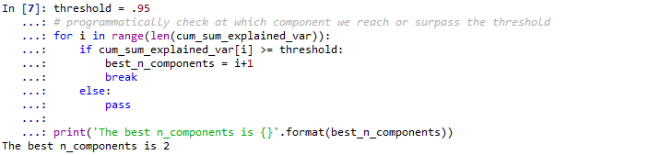

1. To display this visually, we will plot the proportion of explained variance by the number of principal components. First, import matplotlib.pyplot using import matplotlib.pyplot as plt.
2. Create a list of numbers ranging from 1 to the number of principal components and save it as x using x = list(range(1, len(explained_var_ratio)+1)).
3. Save cum_sum_explained_var as y using y = cum_sum_explained_var.
4. Create our plot using plt.plot(x, y, color=’blue’, label=’Explained Variance’).
   1. The arguments x and y are for the number of principal components and cum_sum_explained_var, respectively.
   2. Using ‘blue’ as the argument for color makes the line blue and using ‘Explained Variance’ as the argument for label displays Explained Variance in the plot legend.
5. Create a programmatic title explaining the main information from the plot using plt.title(‘{0} n_components are suggested to preserve {1} of the variance’.format(best_n_components, threshold)).
   1. This yields a title that reads ‘2 n_components are suggested to preserve 0.95 of the variance.’
      1. The 0 in the first {} refers to the first argument in the format function, best_n_components, and the 1 in the second {} refers to the second argument in the format function, threshold.
6. Name the y-axis ‘Proportion of Explained Variance’ using plt.ylabel(‘Proportion of Explained Variance’).
7. Name the x-axis ‘n_components’ using plt.xlabel(‘n_components’).
8. Make sure the x-axis is numbered 1 through 4 (I.e., the maximal number of principal components) using plt.xticks(range(1, len(explained_var_ratio)+1)).
9. Make the visualization easier to comprehend by placing a horizontal, dotted gray line at the level of threshold using plt.axhline(y=threshold, color=’gray’, linestyle=’--’, label = ‘{} Explained Variance’.format(threshold)).
   1. The y argument tells Python at which value to place the horizontal line.
   2. Using ‘gray’ as the value for the color argument tells Python that the line should be gray.
   3. Using ‘--’ as the value for the linestyle argument makes sure the line is dotted.
   4. The label argument tells Python what to label the line in the legend.
      1. Our label is programmatic so if the threshold changes, we would not need to adjust our code.
10. The line plt.legend(loc=’best’) simply creates a plot legend and puts it in the best location to not interfere with the lines in the plot.
11. Display the plot using plt.show().

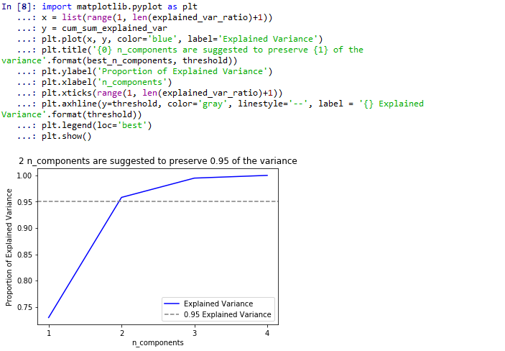

***Note***

Code adapted from (https://towardsdatascience.com/an-approach-to-choosing-the-number-of-components-in-a-principal-component-analysis-pca-3b9f3d6e73fe)

Now, we can refit another PCA model with n_components = 2, transform the data into the principal components, and use these components in a new k-Meansmodel to lower the inertia values. Additionally, we can compare the inertia values across n_clusters values for the models built using PCA transformed data to those using data that was not PCA transformed.

Activity 2: Evaluating mean inertia by cluster after PCA transformation

Now that we know the best number of principal components (I.e., 2), how to transform our features into principal components, and how to tune the optimal number of clusters for k-Means clustering with a nested loop, we will put them all together in this activity. We will also compare the inertia by n_clusters prior to the PCA transformation and after the PCA transformation to see the effect of PCA transformation on k-Means model performance.

After the iris data set has been imported, shuffled, and standardized (see Exercise 1):

1. Instantiate a PCA model with the value for the n_components argument equal to best_n_components (I.e., remember, best_n_components = 2).
2. Fit the model to scaled_features.
3. Transform scaled_features into its first 2 principal components and store it is the array object, df_pca.
4. Using a nested loop, tune the number of n_clusters by calculating the mean inertia over 100 models at values 1 through 10 for n_clusters (see Exercise 4).
5. Visually compare mean inertia by n_clusters using scaled_features to mean inertia by n_clusters using df_pca by plotting both on the same plot.

***Note***

For step 6 to work, mean_inertia_list from Exercise 4 must still be in our environment.

**Solution:**

1. Import the PCA function using from sklearn.decomposition import PCA. Instantiate a PCA model with the value for the n_components argument equal to best_n_components (I.e., remember, best_n_components = 2) using model = PCA(n_components=best_n_components).

***Note***

If we have cleared our environment since exercise 6, we can use model = PCA(n_components=2).



1. Fit the model to scaled_features using model.fit(scaled_features).



1. Transform scaled_features into its first 2 principal components and store it is the array object, df_pca, using df_pca = model.transform(scaled_features).



1. Tune n_clusters by importing the KMeans function using from sklearn.cluster import KMeans and import numpy using import numpy as np.

***Note***

Remember, it is easier to build and comprehend nested loops by working from the inside-out.

Instantiate an empty list, inertia_list, for which we will be appending inertia values after each iteration of the inside loop using inertia_list = []. In the inside loop, we will iterate through 100 models using for i in range(100):.

* 1. Build our KMeans model with n_clusters=x using model = KMeans(n_clusters=x).

***Note***

The value for x will be dictated by the outer loop which is covered in detail below.

* 1. Fit the model to scaled_features using model.fit(scaled_features).
  2. Get the inertia value and save it to the object inertia use inertia = model.inertia_.
  3. Append inertia to inertia_list using inertia_list.append(inertia).

***Note***

After the 100 iterations of n_clusters=x have concluded, inertia_list will contain 100 inertia values; one for each model.

Moving to the outside loop, instantiate another empty list to store the average inertia values using mean_inertia_list_PCA = []. Determine the range of numbers through which we want to iterate for n_clusters. Since we want to check the average inertia over 100 models for n_clusters 1 through 10 we will instantiate the outer loop using for x in range(1, 11):.

***Note***

The value for x will dictate the value for n_clusters and since it is on the outside, it will not move to the next value of x until the inner loop has iterated through its 100 loops.

After the inside loop has run through its 100 iterations, and the inertia value for each of the 100 models have been appended to inertia_list,

* 1. Compute the mean of this list and save the object as mean_inertia using mean_inertia = np.mean(inertia_list).
  2. Append mean_inertia to mean_inertia_list_PCA using mean_inertia_list_PCA.append(mean_inertia).
  3. After 100 iterations have been completed 10 times for a total of 1000 iterations, mean_inertia_list_PCA contains 10 values that are the average inertia values for each value of n_clusters. This allows us to plot mean_inertia by n_clusters and choose the optimal number of n_clusters after the PCA transformation using the, previously described, “elbow” method.

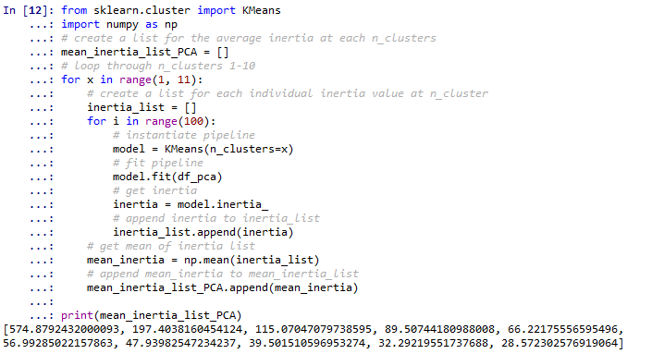

1. Visually compare average inertia by n_clusters after PCA transformation and before PCA transformation by plotting both lines on the same plot. This plot differs from the plot in Exercise 4 in that it has two lines; one for mean inertia before PCA (I.e., mean_inertia_list) and one after PCA transformation (I.e., mean_inertia_list_PCA). To display these on the same plot:
   1. Import matplotlib using import matplotlib.pyplot as plt.
   2. Create a list of numbers and save it as the object x so we can plot it on the x-axis using x = list(range(1,len(mean_inertia_list_PCA)+1)).
   3. Save mean_inertia_list_PCA as the object y using y = mean_inertia_list_PCA.
   4. Save mean_inertia_list as the object y2 using y2 = mean_inertia_list.
   5. Plot mean inertia after PCA transformation by number of clusters using plt.plot(x, y).
   6. Add our second line of mean inertia before PCA transformation by number of clusters using plt.plot(x, y2).
   7. Set the plot title to read ‘Mean Inertia by n_clusters for Original Features and PCA Transformed Features’ using plt.title(‘Mean Inertia by n_clusters for Original Features and PCA Transformed Features’).
   8. Label the x-axis ‘n_clusters’ using plt.xlabel(‘n_clusters’).
   9. Set the tick labels on the x-axis as the values in x using plt.xticks(x).
   10. Set the y-axis label to ‘Mean Inertia’ using plt.ylabel(‘Mean Inertia’).
   11. Display a legend using plt.legend().
   12. Display the plot use plt.show().

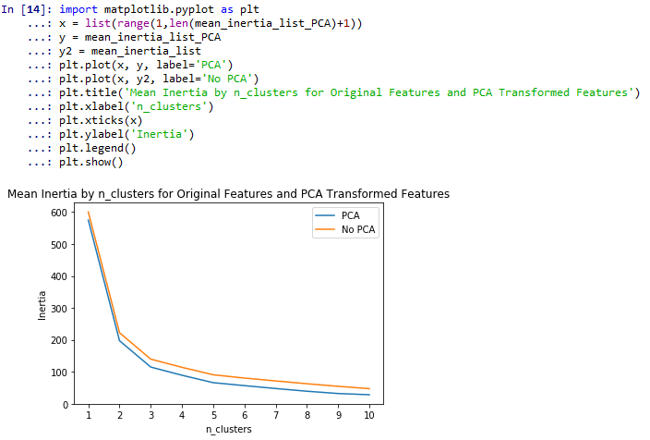

From the plot we can see that inertia is lower at every number of clusters in the model using the PCA transformation. This indicates that there was less distance between the group centroids and the observations in each cluster after the PCA transformation relative to before the transformation. Thus, by using a PCAtransformation on the original features, we were able to decrease the number of features and simultaneously improve our model by decreasing the within-cluster sum of squares (i.e., inertia).

*Discuss: Is there another step we can take to make sure the model with the 2 principal components is the best possible model? Hint: how would we determine mean inertia by number of clusters over a range of thresholds?*

HCA and k-Means clustering are two widely-used unsupervised learning techniques used for segmentation. PCA can be used to help reduce the number of dimensions in our data and improve models. Linear discriminant function analysis (LDA) can do both. For the purposes of this chapter, we will learn how to use LDA as a supervised learner for classification.

Supervised Linear Discriminant Function Analysis (LDA)

*Present 26-27: Brief intorduction of Linear Discriminant Function Analysis*

Linear Discriminant Function Analysis (LDA) is related to MANOVA in that we use MANOVA to identify the linear variates best differentiating the groups. In LDA, the linear variates are the boundaries, or functions, used to discern one group from another (Field, 2013).

*Source: Field, A. (2013). Discovering statistics using IBM SPSS statistics. sage.*

In this example, we will walk through how to use LDA as a classification model via supervised learning. That is, we will be tuning and fitting the LDA model on the training data, testing it on the testing data, and evaluating model performance.

To demonstrate how to use LDA as a classifier for supervised learning we will:

* Fit an LDA model using the algorithm’s default hyperparameter settings
* Tune our LDA hyperparameters using a grid search
* Access LDA attributes by refitting a programmatically tuned LDA model

Exercise 7: Fitting LDA Model with Default Hyperparameters

To fit the model as a supervised learner using the default parameters of the LDA algorithm we must first import the data and the dependent variable. In the previous sections we did not need to import the dependent variable because the learners were unsupervised.

1. Import the iris utilities bunch and save it as the object iris using from sklearn import datasets and iris = datasets.load_iris().



1. Save the features as the data frame df using import pandas as pd and df = pd.DataFrame(iris.data). Then, save the dependent variable as the target column in df using df[‘target’] = iris.target*.*



1. Shuffle the data to remove any ordering effects and save it as the data frame df_shuffled using from sklearn.utils import shuffle and df_shuffled = shuffle(df, random_state=42).



1. Scale df_shuffled by, first, instantiating a StandardScaler() object named scaler using scaler = StandardScaler(). Fit scaler to df_shuffled using scaler.fit(df_shuffled). Transform the features to the scaled features and save them as scaled_features using scaled_features = scaler.transform(df_shuffled).

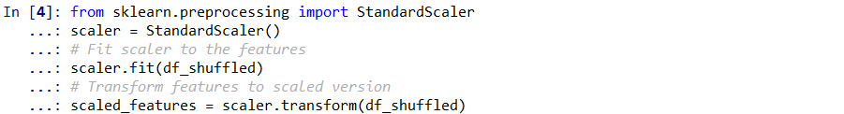

1. Save 'target’ as DV (I.e., dependent variable) to make the code more elegant and flexible using DV = ‘target’.



1. Split the shuffled data into X and yusing X = df_shuffled.drop(DV, axis=1) and y = df_shuffled[DV], respectively*.*



***Note***

By saving *target* as *DV* we do not need to write target in the two places where it refers to DV in step 6. This allows the code to be flexible to different data sets. By saving target as DV ahead of time the dependent variable just needs to be changed in one place rather than several.

Unlike the unsupervised learning examples in previous sections, we will need to split the features (I.e., X) and the target (I.e., y) into testing and training data. For our convenience, Scikit Learn provides us with a function for this named train_test_split. In this example, we are placing 66% of the data into training and 33% in testing.

1. Split X and y into testing and training data using from sklearn.model_selection import train_test_split and X_train, X_test, y_train, y_test = train_test_split(X, y, test_size=0.33, random_state=42).



1. Instantiate the LDA (https://scikit-learn.org/stable/modules/generated/sklearn.discriminant_analysis.LinearDiscriminantAnalysis.htm) model and save it as model. Import the function using from sklearn.discriminant_analysis import LinearDiscriminantAnalysis and model = LinearDiscriminantAnalysis().



***Note***

By instantiating a model with nothing between the trailing parenthesis, we are telling Python that we want to use the default hyperparameters. What are hyperparameters? Hyperparameters are user-defined settings within an algorithm which influence how the model fits and, subsequently performs on the data. Hyperparameters and their available values are listed in the documentation of every algorithm.

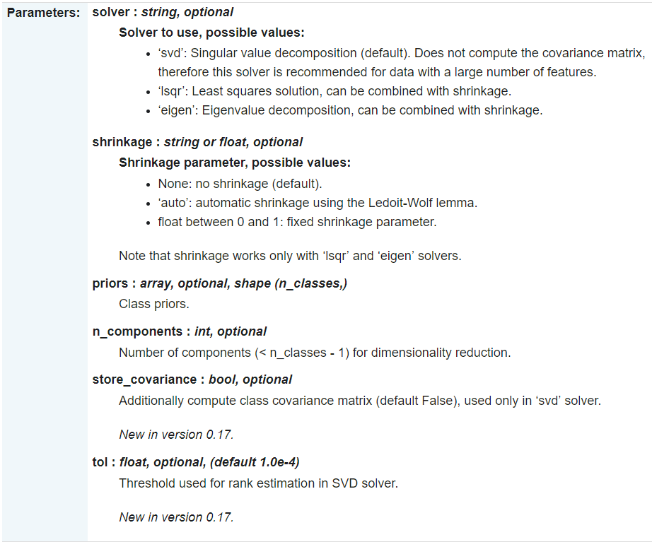

Figure 4.6. Hyperparameters for sklearn.discriminant_analysis.LinearDiscriminantAnalysis

But how do we know the default hyperparameters for an algorithm? In Scikit-Learn, the *default* hyperparameter will be specified in the parameters section of the documentation table. However, if we scroll to the top of the page, we can see the default hyperparameter settings (see Figure 4.7).



Figure 4.7. Default hyperparameters for LDA

Thus, by failing to specify any hyperparameters in our LDA model we are telling Python that we want the ‘svd’ solver, no shrinkage, no priors, no n_components, no covariance matrix, and a tolerance of 0.0001. For detailed descriptions of each hyperparameter, see Figure 4.6.

Now that we are aware of how to make sense of the documentation and the default hyperparameters:

1. Fit the model to the training data using model.fit(X_trian, y_train).



***Note***

In the out area of the above screenshot that the specified hyperparameters are the same as those in Figure 4.7.

1. Generate predictions on X_test and save them as the array, predictions. This will return the predicted class for each observation. Once we have predictions on the test data, we can see how the model performed by comparing predictions to y_test (I.e., actual values).



***Note***

Scikit-Learn provides for us functions that make evaluating model performance very simple. For classification problems we can evaluate model performance using a confusion matrix which compares predicted values to actual values (https://scikit-learn.org/stable/modules/generated/sklearn.metrics.confusion_matrix.html).

1. To generate a confusion matrix, begin by importing the function confusion_matrix using from sklearn.metrics import confusion_matrix. Then, save the confusion matrix into a 3x3 array object using conf_matrix = confusion_matrix(y_test, predictions).

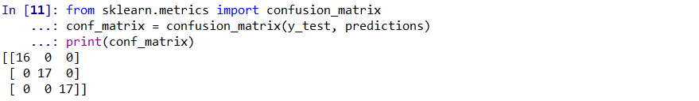

***Note***

This 3x3 array can be difficult to comprehend without guidance. The first, second, and third columns represent predicted 0, predicted 1, and predicted 2, respectively. The first, second, and third rows represent actual 0, actual 1, and actual 2, respectively.

1. Make conf_matrix less confusing by adding some styling:
   1. Convert conf_matrix into a pandas data frame named cm using import pandas as pd and cm = pd.DataFrame(conf_matrix).
   2. Create a new column named ‘Total’ which contains the row totals by importing numpy using import numpy as np and cm[‘Total’] = np.sum(cm, axis=1).
   3. Compute a row containing the column total using cm = cm.append(np.sum(cm, axis=0), ignore_index=True).
   4. Assign names to the columns in cm using cm.columns = ['Predicted 0', 'Predicted 1', 'Predicted 2', 'Total'].
   5. Assign the row names (I.e., indices) using cm = cm.set_index([['Actual 0', 'Actual 1', 'Actual 2', 'Total']]).

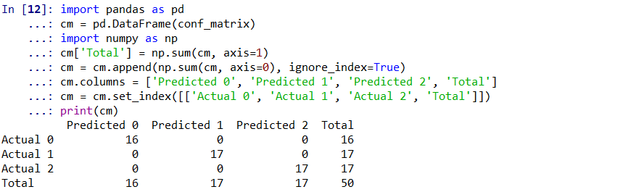

***Note***

The confusion_matrix function, in this case, returns a 3x3 array with no labels. Here, we have converted it into a pandas data frame, created a *Total* column, created a *Total* row, named the columns, and named the row indices. It is easier to interpret this way and can be saved as a csv or excel file with a single line of code using the to_csv function.

To interpret this output, think in terms of true positives (TP), false positives (FP), true negatives (TN), and false negatives (FN):

* TP: observation predicted to be in a certain class and is in that class (I.e., a correct prediction).
* FP: observation predicted to be in a class but is not in that class (I.e., an incorrect prediction).
* TN: observation predicted not to be in a certain class and is not in that class (I.e., a correct prediction).
* FN: observation predicted not to be in a certain class and is in that class (I.e., an incorrect prediction).

From the 3x3 confusion matrix, we can see that of the 16 observations that were in class *0*, all 16 were predicted to be in class *0*. Of the 17 observations that were in class *1*, all 17 were predicted to be in class *0*. Of the 17 observations that were in class *2*, all 17 were predicted to be in class *2*.

*Discuss: Are we surprised at how well this model performed? Will 100% accuracy happen in a real life situation? How might we make sure we have the best possible combination of hyperparameters?*

LDA’s default settings predicted with 100% accuracy on this data. However, this would be almost unheard of in real life and, often, the best combination of model hyperparameters must be found. This is referred to as tuning the model. Scikit learn provides an outstanding library for tuning models called *GridSearchCV* (<https://scikit-learn.org/stable/modules/generated/sklearn.model_selection.GridSearchCV.html>).

Exercise 8: Tuning LDA Hyperparameters using GridSearchCV

Grid search builds a model for all combinations of hyperparameters, evaluates each model’s performance, and picks the ‘best’ combination of hyperparameters according to a metric set by the user inside of the GridSearchCV function. Algorithms with a large number of hyperparameters and/or ranges of values can take a long time to perform a grid search; especially on larger data sets. Luckily, in the following example we are using a small data set with few hyperparameters and each hyperparameter has few possible values.

After the data has been imported, shuffled, scaled, and split into testing and training data (see Exercise 7):

1. Instantiate a grid with the possible values for each hyperparameter as key value pairs in a dictionary using grid = {'solver': ['lsqr', 'eigen'], 'shrinkage': [None, 'auto']}.

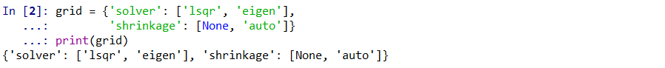

***Note***

Here, we provide 2 hyperparameters for which to tune and each hyperparameter has 2 possible values. In the GridSearchCV function, we provide arguments for estimator (I.e., LinearDiscriminantAnalysis()), param_grid(I.e., *grid*), scoring (I.e., *accuracy*), and cv(I.e., *5*). The scoring argument has several possible values that are available on the documentation (https://scikit-learn.org/stable/modules/model_evaluation.html#scoring-parameter).

Here, we have specified that we want the model with the combination of hyperparameters that will optimize accuracy. Accuracy is the proportion of predictions that were correctly classified and is defined:

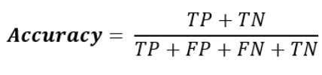

Equation 4.3. Accuracy.

1. Instantiate a GridSearchCV model with accuracy as the scoring outcome for which we will be maximizing. To import GridSearchCV use from sklearn.model_selection import GridSearchCV and to import LinearDiscriminantAnalysis use from sklearn.discriminant_analysis import LinearDiscriminantAnalysis. To instantiate the GridSearchCV model use model = GridSearchCV(LinearDiscriminantAnalysis(), grid, scoring='accuracy', cv=5).



1. Fit the model to the training data using model.fit(X_train, y_train).

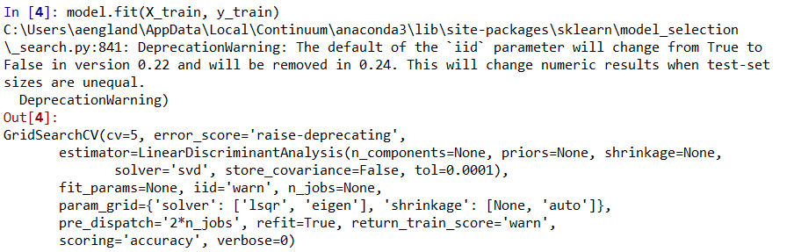

***Note***

From the grid search, we can see that the hyperparameters that optimized accuracy were no shrinkage and an *lsqr* solver. However, there is an easier way to find these by using the best_params_ attribute from GridSearchCV.

1. Save the best parameters as a dictionary using best_parameters = model.best_params_.



1. Generate predictions on X_test using predictions = model.predict(X_test).



1. Evaluate performance by comparing the predictions to y_testwith a styled confusion matrix (for instructions, see Exercise 7, part 12).

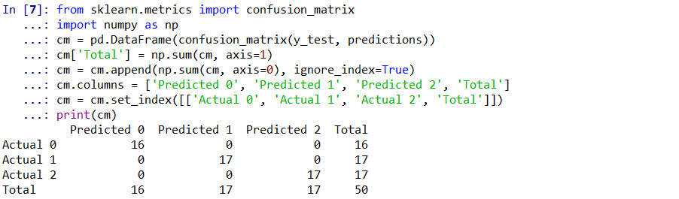

GridSearchCV contains numerous useful and interesting attributes, a drawback of using a GridSearchCV model is that some of the attributes we may want to access from our LinearDiscriminantAnalysis model are not accessible when we fit a GridSearchCV model. However, we can access those attributes by refitting a new LinearDiscriminantAnalysis model with the tuned hyperparameters. This can be done by copying and pasting the values from best_parameters, with their coinciding hyperparameter. However, that requires manual intervention and introduces room for possible errors. To automate the process, we can programmatically access the values from best_parameters and store those values as the hyperparameters. This method becomes increasingly useful when tuning models in an ensemble with RandomizedSearchCV (https://scikit-learn.org/stable/modules/generated/sklearn.model_selection.RandomizedSearchCV.html).

1. Import the LinearDiscriminantAnalysis function using from sklearn.discriminant_analysis import LinearDiscriminantAnalysis. Instantiate the new LinearDiscriminantAnalysis model with programmatically tuned hyperparameters using model = LinearDiscriminantAnalysis(solver=best_parameters['solver'], shrinkage=best_parameters['shrinkage']).



1. Fit the model using model.fit(X_train, y_train).



Now, we not only have access to the predict attribute and others from the GridSearchCV function, but also attributes such as coef_, intercept_, covariance_, means_, priors_, and classes_.

***Note***

Fitting a model using GridSearchCV can be extremely time consuming if the data contains many features and/or large ranges of hyperparameters. Additionally, the scoring argument can be adjusted for supervised learning models such as classification and regression as well as unsupervised models (i.e., clustering). It is important to become familiar with the documentation for GridSearchCV and RandomizedSearchCV to make model-tuning more efficient and maximize model performance.

*Discuss: Use cases for programmatically selecting tuned hyperparameters and refitting tuned parameters? Hint: feature performance in ensembles of XGBoost (trees), Decision Trees, and Random Forests using RandomizedSearchCV.*

Conclusion

This chapter introduced the reader to two widely-used unsupervised, clustering algorithms, *HCA* and *k-Means clustering*. While learning about *k-Means clustering*, we leveraged the power of loops to create ensembles of models for tuning the number of clusters and to gain more confidence in our predictions. During the *PCA* section, we determined the number of principal components for dimensionality reduction and fit the components to a *k-Means* model. Additionally, we compared the differences in *k-Means* model performance before and after *PCA* transformation. Lastly, we were introduced to an algorithm, *LDA*, which can be used for dimension reduction or classification. We then tune LDA hyperparameters using *GridSearchCV*. Along the way, we learned to evaluate classifier model performance using a confusion matrix. This was a comprehensive chapter aiming to teach dimensionality reduction and unsupervised learning in progressively challenging and creative ways. By the end of the chapter, students should understand clustering techniques, the benefits of dimensionality reduction, and methods for hyperparameter tuning.